

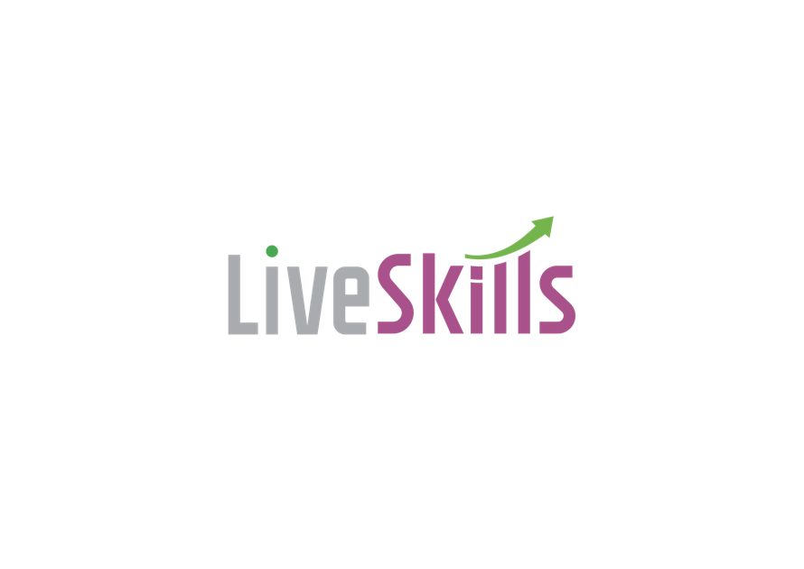

About Us:

E-skilling is the new age way of learning. At LiveSkills, the online skilling journey is coupled with a job guarantee proposition assuring learners of the relevance and alignment of the course with the precise job requirement. We set the standard for excellence in online skilling and training. Our platform is a comprehensive stride towards enabling professionals and organizations to become upgraded and upskilled.

Key Responsibilities:

* Make outbound calls to prospective learners who have expressed interest in our courses.
* Provide information about our e-skilling platform, courses, and benefits.
* Engage in persuasive conversations to encourage course enrollment.
* Listen actively to learners' needs and concerns.
* Offer personalized guidance on course selection based on individual goals and aspirations.
* Address any questions or concerns potential learners may have.
* Maintain a systematic follow-up process to nurture leads and convert them into enrolled learners.
* Keep accurate records of interactions and learner information.
* Generate reports on Tele-calling activities and conversion rates.
* Collaborate with the marketing and sales teams to develop effective strategies for lead generation and conversion.
* Provide feedback on learner preferences and market trends to improve our offerings.

Qualifications:

* A bachelor's degree in psychology, counselling, or a related field is preferred.
* Proven experience in tele-calling or counselling roles.
* Excellent communication and interpersonal skills.
* Empathetic and patient listener.
* Strong persuasion and negotiation abilities.
* Goal-oriented with a track record of achieving targets.
* A passion for e-learning and a strong belief in its benefits.
* Ability to work independently and as part of a team.



Mail us at: [info@liveskillsglobal.com](mailto:info@liveskillsglobal.com)

Website: www.liveskillsglobal.com

GST : 09AAECL6908K1Z3

CIN : U80220UP2021PTC149552

